Access Data Analysis Views from Windows authenticated users

- Create a folder ie. Olap in C:\inetpub\wwwroot directory
- Copy all the files from the C:\Program Files\Microsoft SQL Server\MSSQL.1\OLAP\bin\isapi folder into the C:\inetpub\wwwroot\olap .
- Create a new Application Pool for Olap.

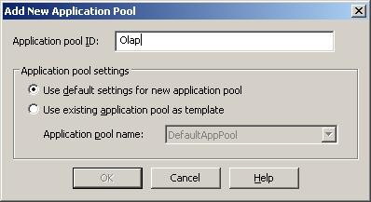

- Create a new website.
- Create a new virtual Directory inside earlier created website.
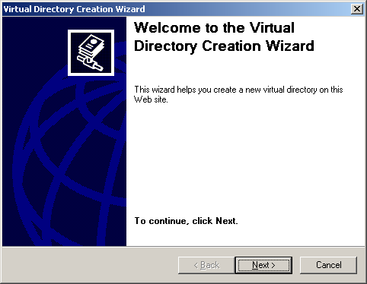
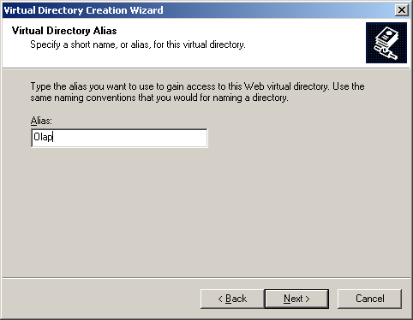

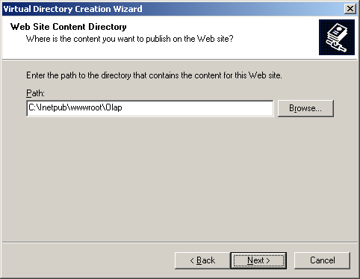

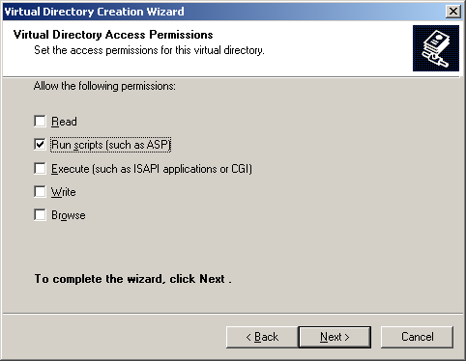

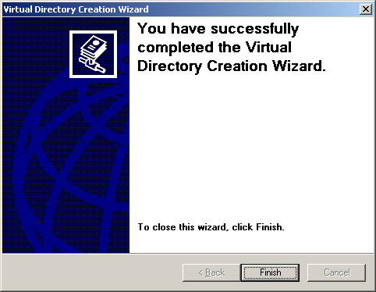

- Right click on Olap virtual Directory and click on properties

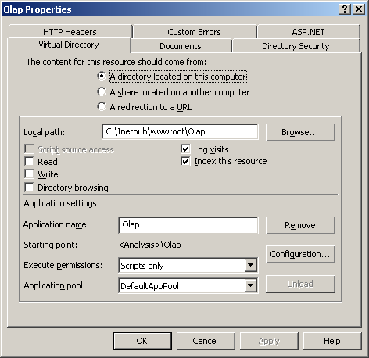

- Select Application Pool which we created earlier.
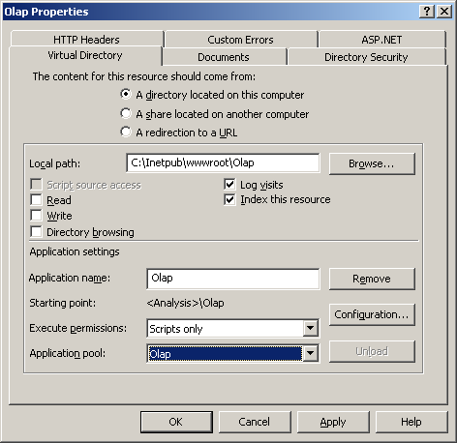

- Click on Configuration tab.

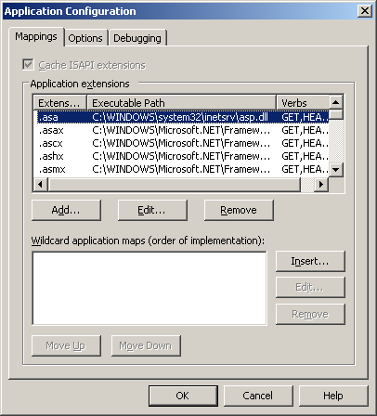

- Click on Add Button
- Enter Executable : C:\Inetpub\wwwroot\Olap\msmdpump.dll
Extension: .dll

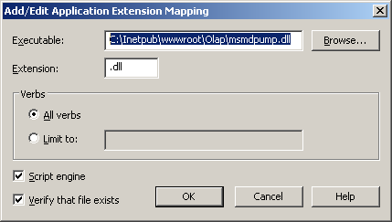

- Click on Directory Security

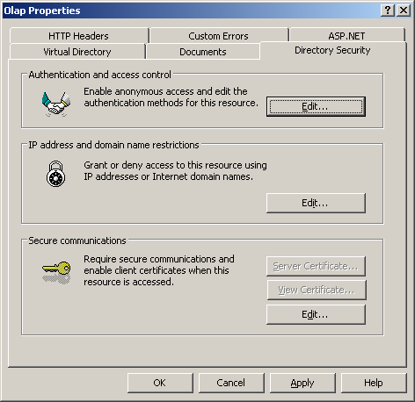

- Click on edit
- Check Integrated Windows Authentication.
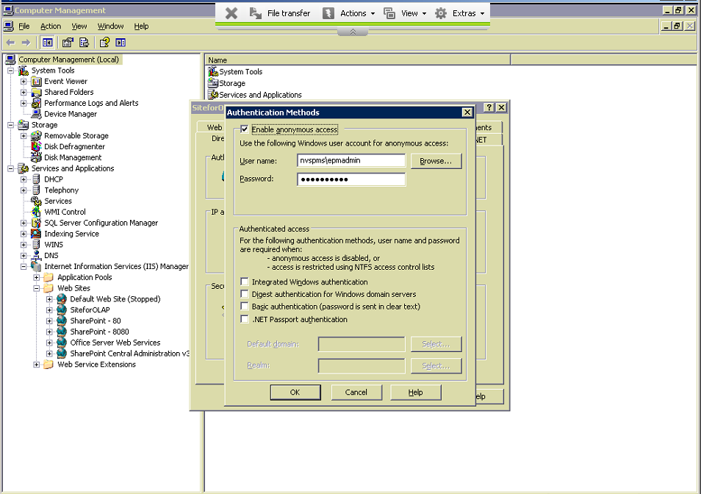

- Right click on earlier created website and click on properties.
- Click on Directory Security tab.
- Click on edit.
- Check anonymous access and add the domain user.
- Explore earlier created ie. Olap virtual directory
- Open msmdpump.ini file.
- Paste this code and remove earlier one.

<ConfigurationSettings>
<ServerName>localhost</ServerName>
<SessionTimeout>3600</SessionTimeout>
<ConnectionPoolSize>100</ConnectionPoolSize>
<MinThreadPoolSize>0</MinThreadPoolSize>
<MaxThreadPoolSize>0</MaxThreadPoolSize>
<MaxThreadsPerClient>4</MaxThreadsPerClient>
</ConfigurationSettings>

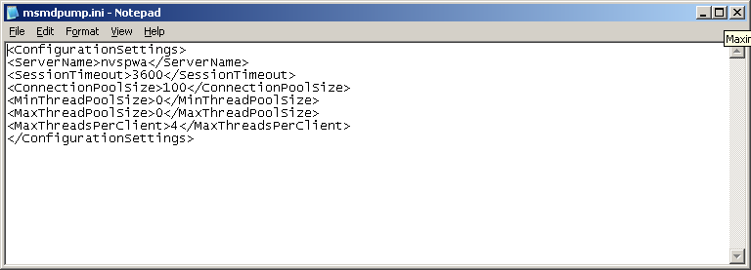

- Create a new Web Server Extension

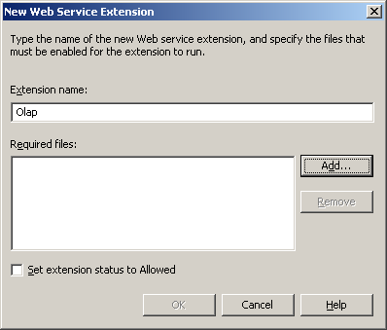
- Click on Add Button
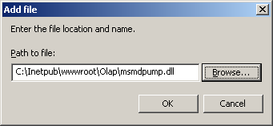
- Click on Web Server Extension
- Check whether Olap extension is allowed.
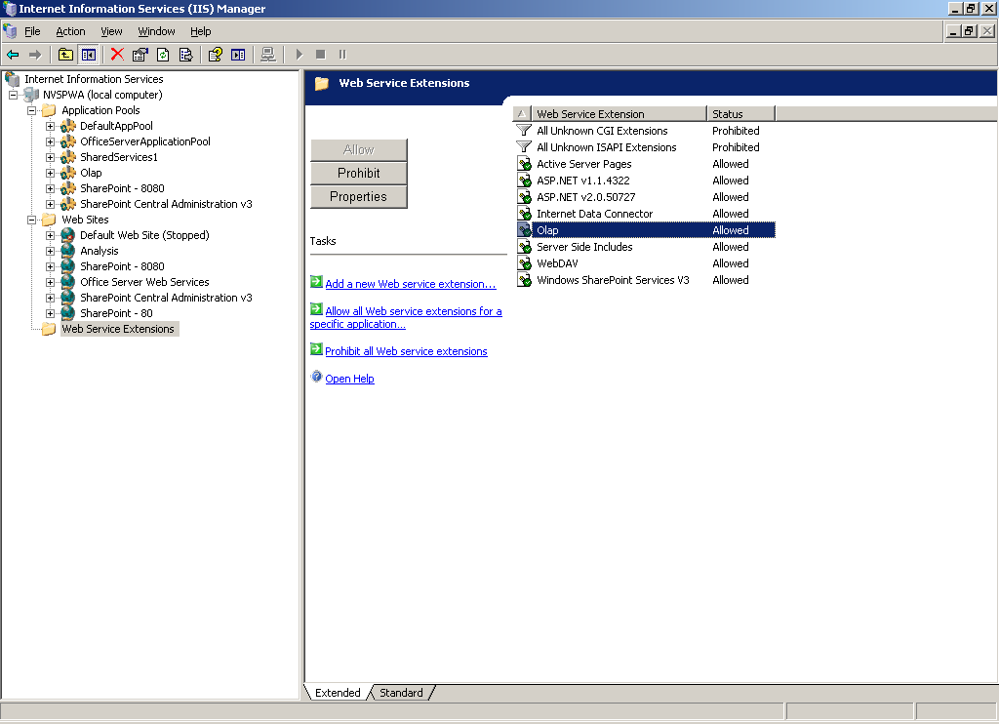

- Reset IIS

Go to Server Settings -> Build Settings

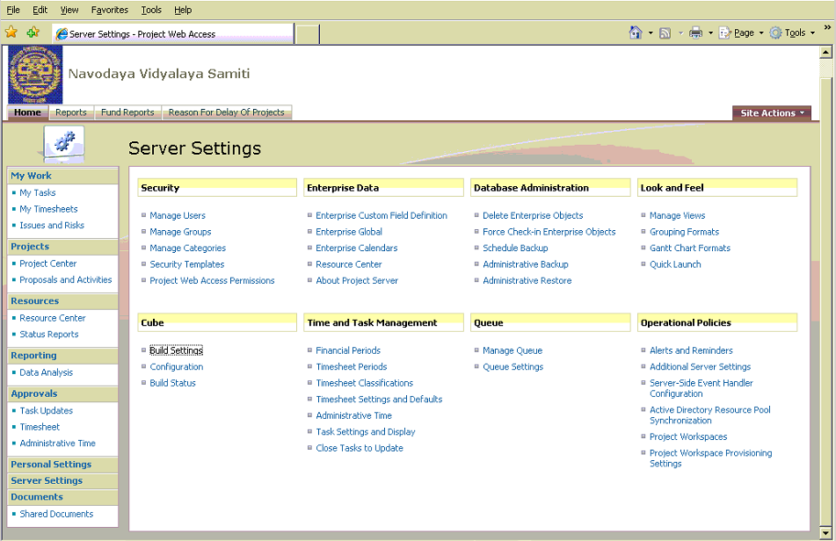
Add the http (http://www.pmsnvs.nic.in:8000/olap/msmdpump.dll)for Analysis Services Server.
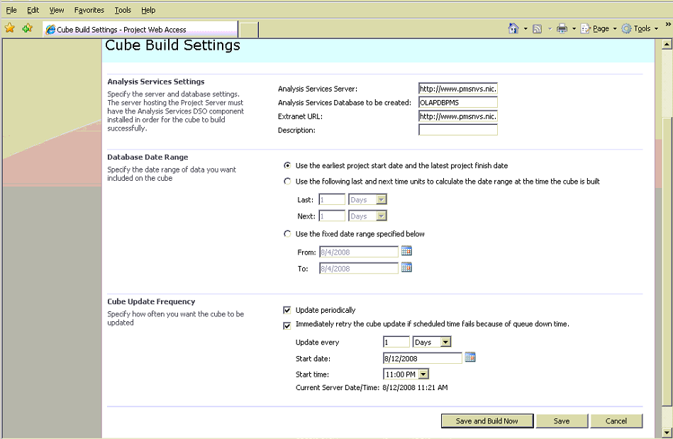
Build Cube
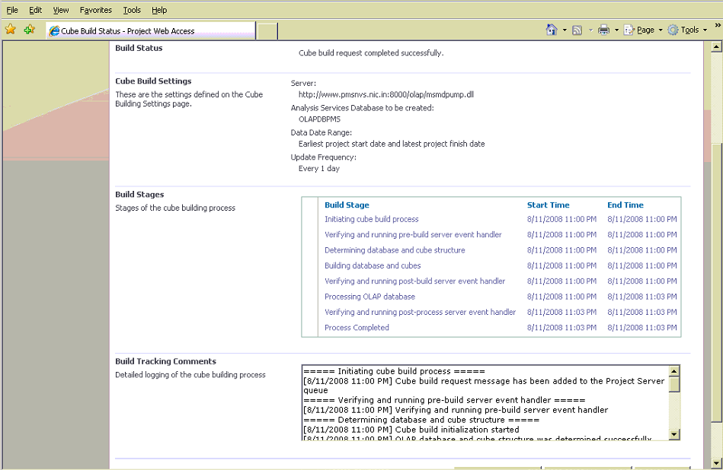

Create a view and provide the extranet address
(i.e http://www.pmsnvs.nic.in:8000/olap/msmdpump.dll)
